# Waves & Wonders: Your Philippine Escape Site Plan

## Angelique Legaspi

## WDD 130

## Overview

### Purpose

The purpose of this website is to inspire and guide travelers interested in exploring the Philippines by offering local insights into must-visit islands, activities, food, and cultural tips. It’s a digital travel guide created from the perspective of a local, making it more personal and authentic than standard tourism sites.

### Audience

International tourists, Filipino Americans rediscovering their roots, backpackers, and nature lovers who are planning to travel to the Philippines or are simply curious about it. The site also appeals to people seeking travel inspiration, helpful planning tools, and cultural understanding.

## Branding

### Website Logo



## Style Guide

### Color Palette

|  |  |  |  |
| --- | --- | --- | --- |
| **Primary** | **Secondary** | **Accent 1** | **Accent 2** |
| #0b16ee | #FFD100 | #CE1126 | #0bee31 |

### Typography

#### Heading Font: [Verdana, Geneva, sans-serif]

#### Paragraph Font: [Trebuchet MS, Helvetica, sans-serif]

### Navigation

Home Destination Travel Tips

**Content**

### ****Home Page****

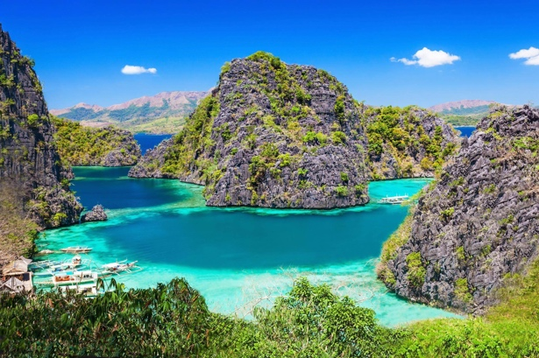

* **Image:**
* **Welcome Message:**  
  “Welcome to Waves & Wonders – your local-inspired travel guide to the Philippines. Discover hidden beaches, authentic food, and local travel tips for the adventure of a lifetime!”
* **Featured Destinations Preview:**

**Palawan**

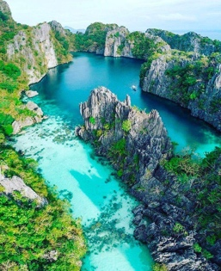

Known as the “Last Frontier,” Palawan is a dreamland of limestone cliffs, secret lagoons, and turquoise waters.

**Cebu**

A perfect blend of city life and nature.

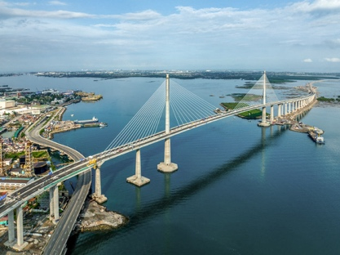

**Bohol**

Bohol offers a mix of nature and adventure.

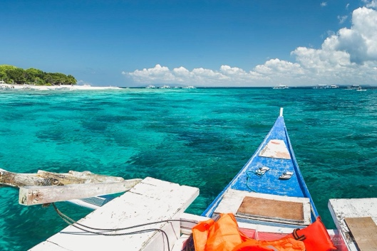

* **Call to Action:** “Start Exploring” button linking to Destinations page

**Destinations Page**

**Title:** Top Island Escapes

### 🌴 Discover Palawan: The Philippines’ Last Frontier

Palawan is a tropical paradise known for its crystal-clear waters, dramatic limestone cliffs, and lush jungles. Whether you're an adventurer, nature lover, or just looking to unwind, Palawan has something for everyone.

#### 🏝️ Must-Visit Spots:

* **El Nido** – Famous for its stunning lagoons, hidden beaches, and island-hopping tours.

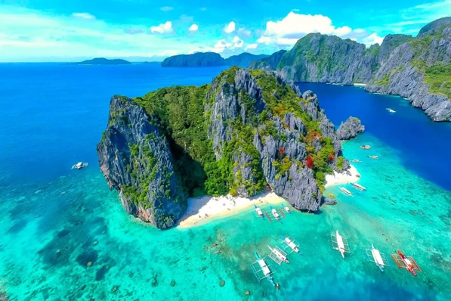

* **Coron** – A diver’s dream with WWII shipwrecks, Kayangan Lake, and hot springs.

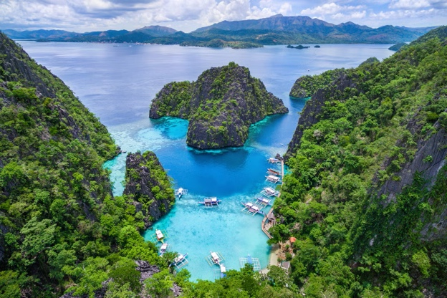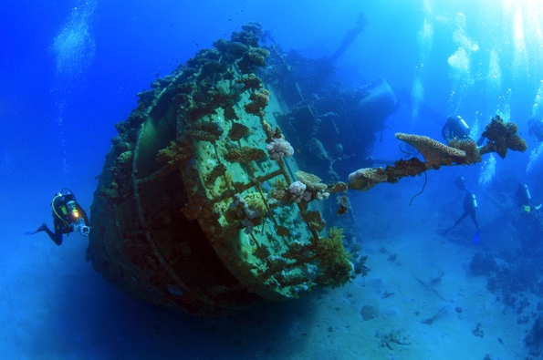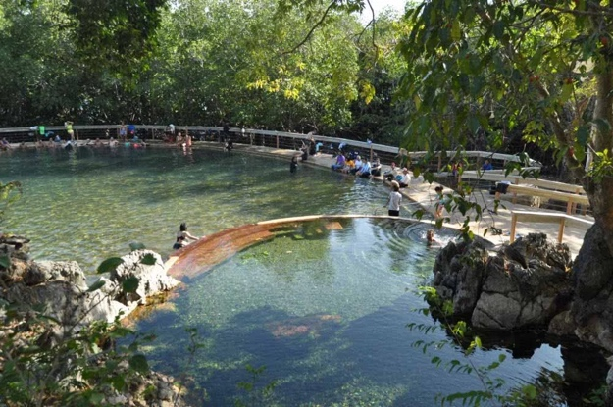

* **Puerto Princesa** – Home to the **Underground River**, one of the New 7 Wonders of Nature.

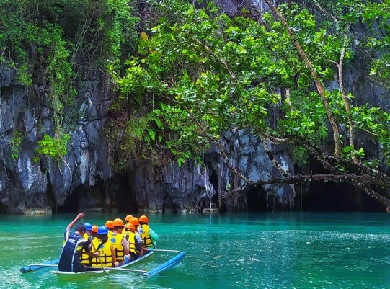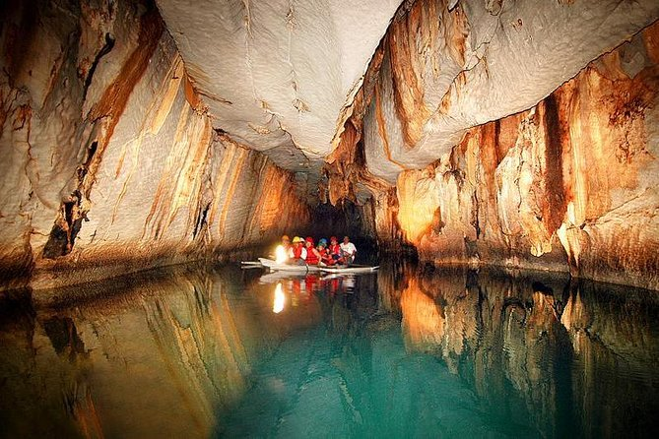

**Food must try:**

**[Tamilok:](https://www.google.com/search?sca_esv=ccb8066356fd07b7&rlz=1C5LTRN_enUS1158US1159&cs=0&sxsrf=AE3TifNlsCj6ph6Ly5o0Dl0DIVsCbCpWvA%3A1750790852832&q=Tamilok&sa=X&ved=2ahUKEwiSy7GW3IqOAxXpOjQIHaPiBAYQxccNegQIPhAD&mstk=AUtExfCHkHO1eWzq1TRIzW9v0peWc6w_uc09A04P-znznt3n0z6saN4BcVToFwzlmJmwkupKGQeef38iS4HBlvhME37e9pXLkqZnR_MwrK1oDTSPPzxrpbyuW-fu65SoHvhmp5fxXj01QCPdzNBEnB8x7TDgV5JNaF0nQXU-76KQEOuG1Kzsex18pF0Wjchk_JbTGWaavRCSD4SMQZjibLRe4nrNzDaIoyYPqSOuSAueP6ZQ9IE9a80CNiU1ZB6ZZYyyLPCU7xrTkJ7_0OamE9Q0PCZfE8fNNQslwHK5fwu08Jc6UA&csui=3" \t "_blank)**

This unique dish is made from a woodworm found in mangrove trees. It's often served raw with vinegar and spices, offering a tangy and earthy flavor.

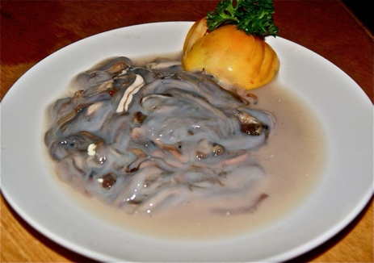

**Seafood:**

As an island province, Palawan boasts a wide array of fresh seafood. Popular choices include tuna, shrimp, blue marlin, crab, lobster, seabass, and squid, prepared in various local styles.

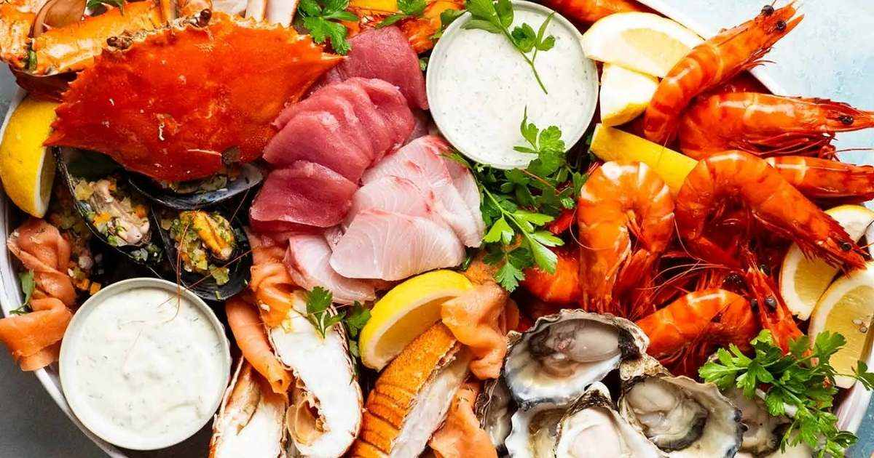

**Crocodile Sisig:**

A spin on the traditional pork sisig, this dish features crocodile meat cooked with onions, chili, and other spices, resulting in a smoky and slightly gamey flavor.

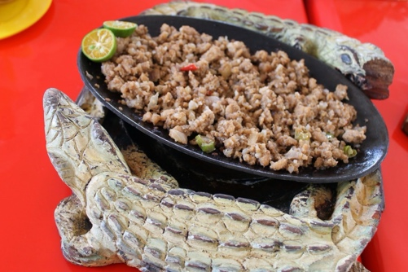

Kinabuchs Grill and Bar

This restaurant in Puerto Princesa is a great place to try Tamilok and Crocodile Sisig.

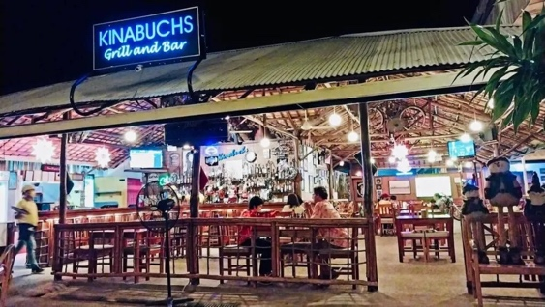

**🌴 Discover Cebu: The Queen City of the South**

Cebu is a vibrant island that perfectly blends city life, history, nature, and beaches. From centuries-old churches to world-class diving spots, Cebu is a must-visit for any traveler in the Philippines.

🌟 Must-Visit Spots:

**Kawasan Falls** – A stunning multi-layered waterfall in Badian, perfect for canyoneering and swimming.

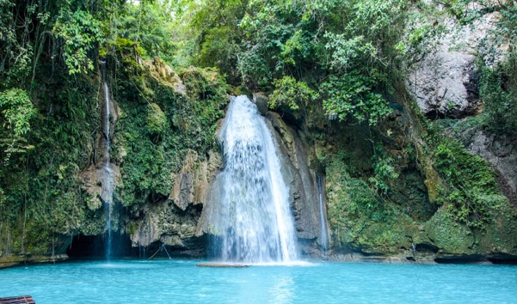

**Oslob** – Famous for whale shark watching and nearby Tumalog Falls.

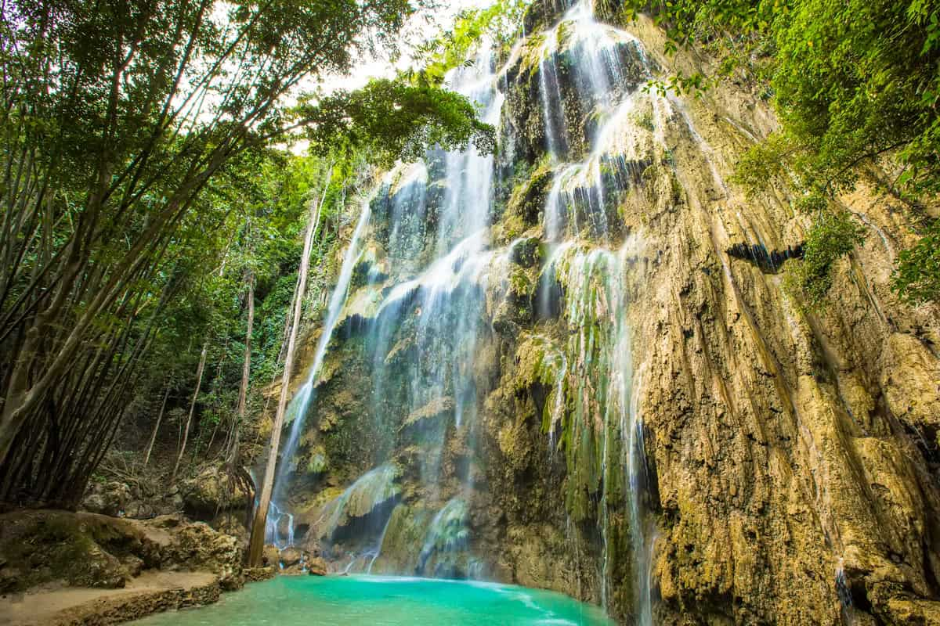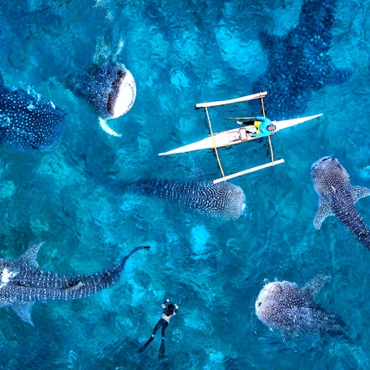

**Moalboal Sardine Run** – Swim with thousands of sardines just a few meters off the shore in Panagsama Beach. No boat needed, just snorkel and enjoy the magic!

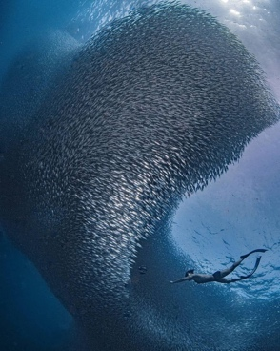

**Bantayan Island** – A peaceful island escape with powdery white sand and crystal-clear water.

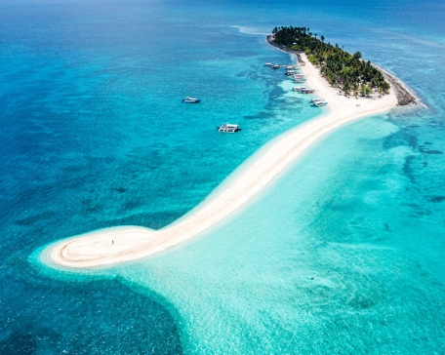

For each island, include:

* **Image of the island**

**Tops Lookout** – Enjoy panoramic views

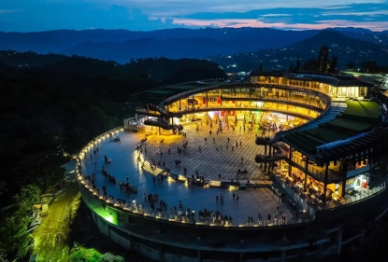

**Food must try:**

**Lechon Cebu** – Known as the best lechon (roast pig) in the Philippines!  
Where to try: **Rico’s Lechon**, **CNT Lechon**, or **House of Lechon** in Cebu City.

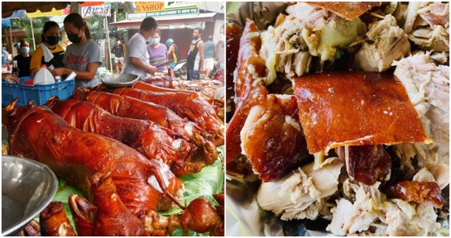

**Puso (Hanging Rice)** – Rice wrapped in woven coconut leaves, perfect with grilled dishes.  
Where to try: Local carinderias, BBQ stalls, or paired with lechon.

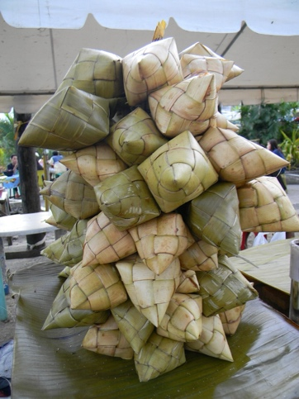

**Ngohiong** – Cebu’s crunchy version of spring rolls with a flavorful twist.  
 Where to try: **Doming’s Ngohiong** or local eateries in the city.

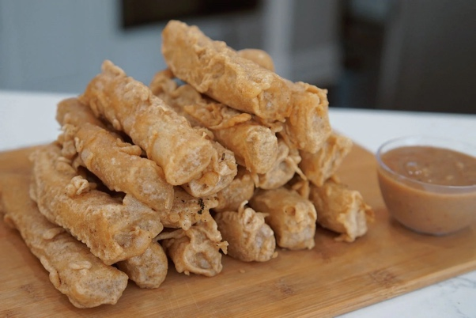

🏝️ **Discover Bohol: Nature, Adventure, and Heritage:**

**Chocolate Hills** – Over 1,000 grass-covered hills that turn brown in the dry season. It’s Bohol’s most iconic attraction!

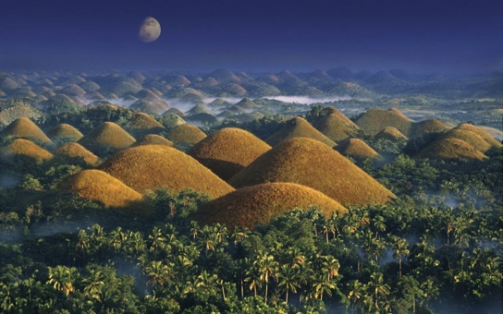

**Tarsier Sanctuary** – Visit one of the world’s smallest primates at the **Philippine Tarsier Conservation Area** in Corella.

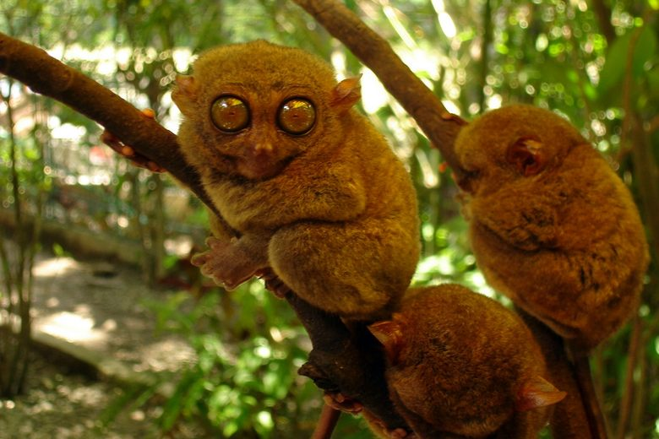

**Loboc River** – Enjoy a peaceful river cruise with a buffet meal and live music onboard. As well as Kayaking.

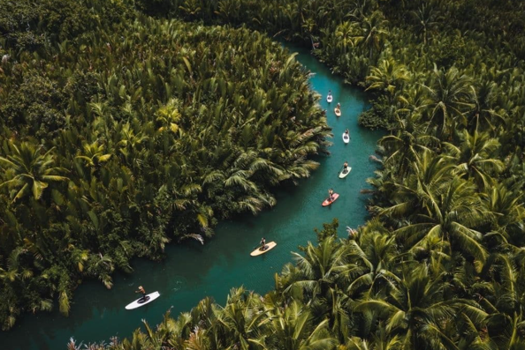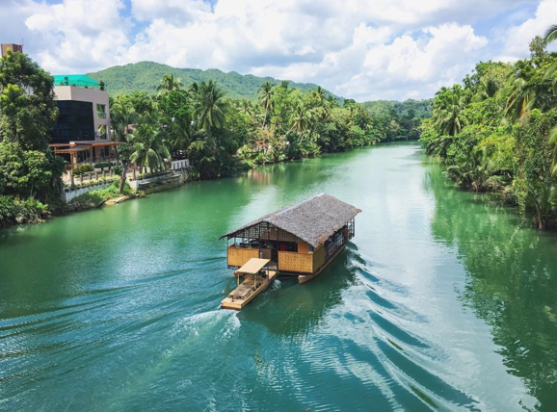

**Panglao Island** – Famous for white sand beaches, island hopping, and diving spots like Balicasag Island.

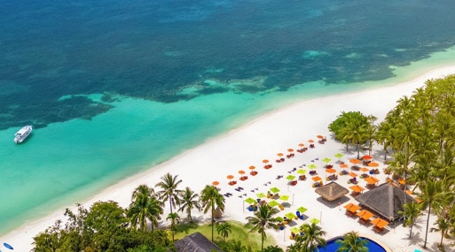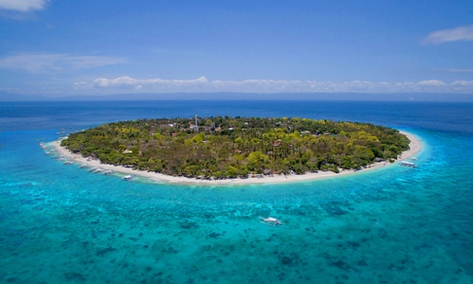

**Food must try:**

**Peanut Kisses** – A crunchy, sweet meringue cookie made with local peanuts.  
Where to get: Souvenir shops or **Island City Mall** in Tagbilaran.

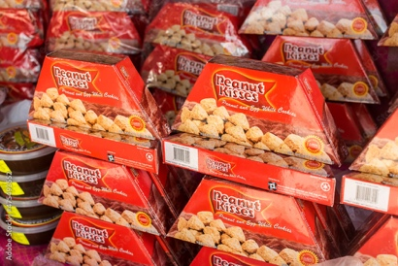

**Calamay** – A sticky sweet treat made from glutinous rice, coconut milk, and brown sugar, packed in coconut shells.  
Where to get: **Baclayon Market** or local souvenir stands.

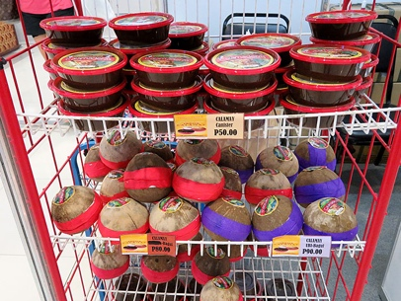

**Organic Ice Cream** – Homemade, coconut-milk sweetened scoops served in cassava “cabcab” cones.

Where to get: The Buzz Café and The Buzzz Ice Cream Stall.

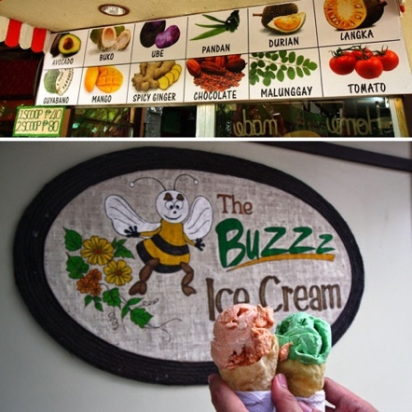

🏝️ **Explore Boracay: White Beaches, Island Vibes & Foodie Paradise**

Boracay's stunning white-sand shores, vibrant marine activities, and laid-back nightlife make it a bucket-list destination.

**White Beach (Stations 1–3)** – The iconic stretch of powdery sand, perfect for sunbathing, swimming, and sunset strolls.

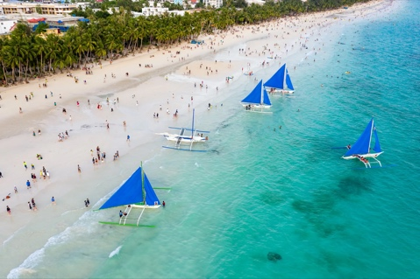

**Puka Shell Beach** – A quieter alternative at the northern tip, known for its natural shells and relaxed vibe.

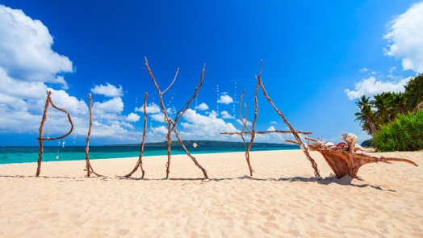

**Willy’s Rock Sanctuary** – A scenic rock chapel landmark that makes for a great photo backdrop.

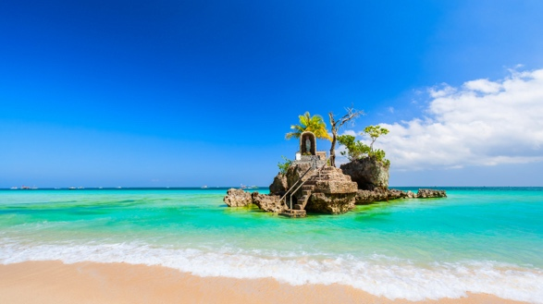

**Paraw Sailing at Sunset** – Catch one of Boracay’s traditional outriggers gliding across the horizon at dusk.

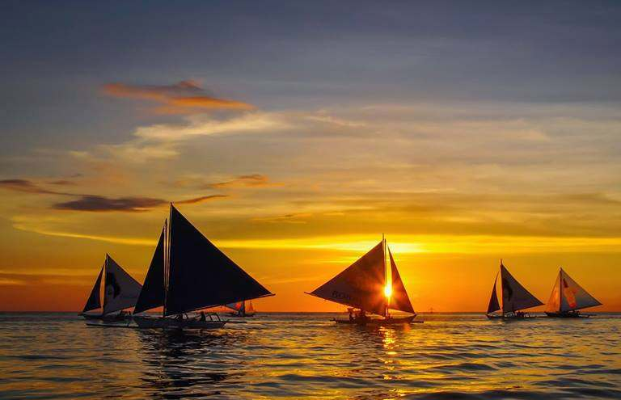

**Other popular activities:**

* Helmet diving
* Scuba diving

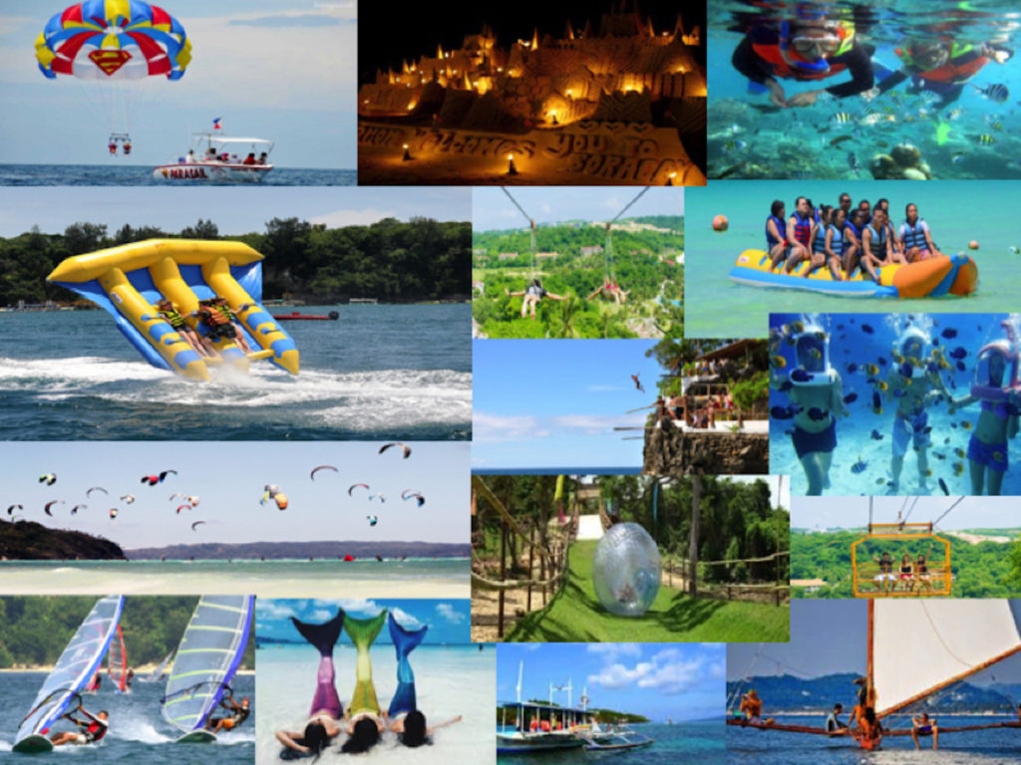

* Snorkeling
* Paddleboarding
* Jet skiing
* Banana boat ride
* Parasailing
* Kite surfing (at Bulabog Beach)
* ATV island tour
* Zipline and cable car
* Spa and massage by the beach
* Sunset cruise
* Pub crawl
* Fire dancing shows
* Henna tattoo
* Shopping at D’Mall
* Sandcastle building
* Yoga on the beach
* Mermaid swimming experience

### ****Food must try:****

### A popular Filipino dessert with shaved ice, sweet beans, fruits, leche flan, ube, and ice cream. 📍 Where to get: **Coco Mama** at D’Mall

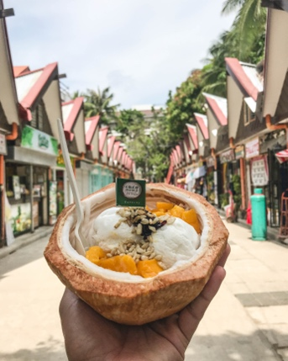

Boracay is famous for tropical shakes like mango, watermelon, banana, and avocado.  
📍 Where to get: **Jonah’s Fruit Shake** (Station 1 or 2)

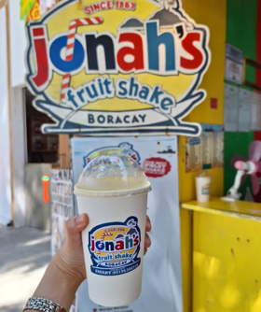

**Seafood from D'Talipapa**

Choose your own fresh seafood (crabs, prawns, squid, fish, lobster) at the market and have it cooked at nearby restaurants—grilled, fried, in butter or sinigang.  
📍 *Where to get:* **D’Talipapa Market** (Station 2)

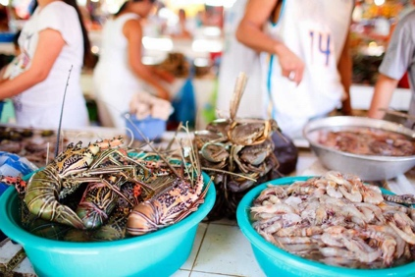

**✈️ Travel Tips**

Planning your adventure in the Philippines? These travel tips will help you make the most out of your island escape smooth, safe, and unforgettable!

**🧳 What to Pack**

* **Light, breathable clothing** – It’s tropical! Bring shorts, tees, sundresses, and a light jacket for boat rides.
* **Swimwear & rash guard** – Essential for beach days, snorkeling, and island hopping.
* **Waterproof dry bag** – Protect your phone, wallet, and gadgets during boat rides and waterfall adventures.
* **Sunscreen & bug spray** – The sun can be strong, and some areas have mosquitoes—especially near rivers or forests.
* **Reusable water bottle** – Stay hydrated and eco-friendly while you explore.

**🚐 Getting Around**

* **Tricycles & Habal-Habal** – Local and affordable transport in towns and small islands.
* **Jeepneys** – Colorful and cheap public rides for short distances.
* **Van & Car Rentals** – Good for groups or road trips in places like Bohol or Cebu.
* **Ferries & Fast Crafts** – Used for inter-island travel (e.g., Cebu to Bohol).
* **Flights** – For long-distance travel between major islands like Manila, Palawan, and Boracay.

**📱 Staying Connected**

* Buy a local **SIM card (Globe or Smart)** at the airport or convenience stores for affordable data.
* Most hotels, restaurants, and cafés offer **free Wi-Fi**, but it can be spotty in remote areas.

**🍴 Food Safety & Etiquette**

* Eat at places that are busy and well-reviewed—**local carinderias** or food markets are gems!
* Ask if the water is safe to drink—when in doubt, go for **bottled or purified water**.
* Try **local delicacies** like lechon, kinilaw, mangoes, and calamansi juice.
* Don’t forget to say "**Salamat po**" (Thank you, respectfully) to locals—it goes a long way.

**💡 Island Travel Tips**

* **Cash is king** – Bring enough pesos when going to remote areas; ATMs aren’t always available.
* Respect **local customs and nature**—leave no trash, follow marine protection rules, and ask before taking photos of people.
* Wake up early to **avoid crowds** and catch the best sunrise views!
* **Weather check** – The dry season (Nov–May) is ideal for most outdoor activities.

**❤️ Local Advice**

* Be friendly! Filipinos are warm, helpful, and love tourists who appreciate their culture.
* Learn a few words:
  + *Hello* – “Kumusta”
  + *Thank you* – “Salamat”
  + *Goodbye* – “Paalam”
* Always **negotiate prices** politely at markets or when hiring boats/trikes.

**✅ Final Tip**

**Plan a little, explore a lot.** Some of the best memories in the Philippines come from unplanned island discoveries, quiet beaches, and spontaneous adventures.

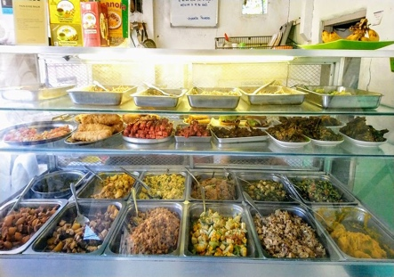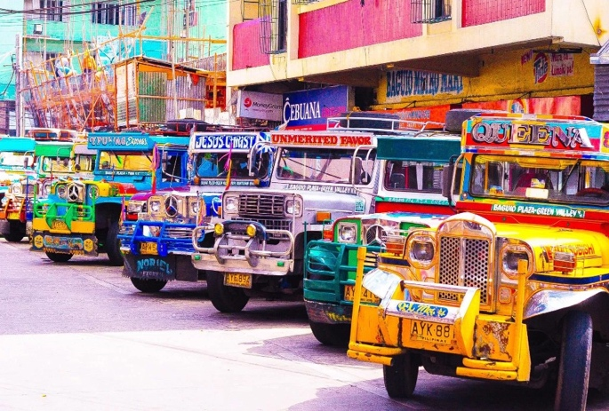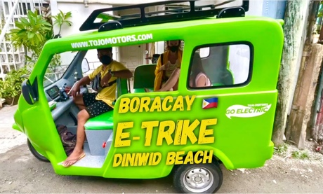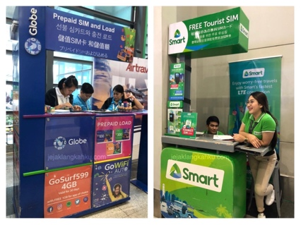

**Wireframes**

### Home

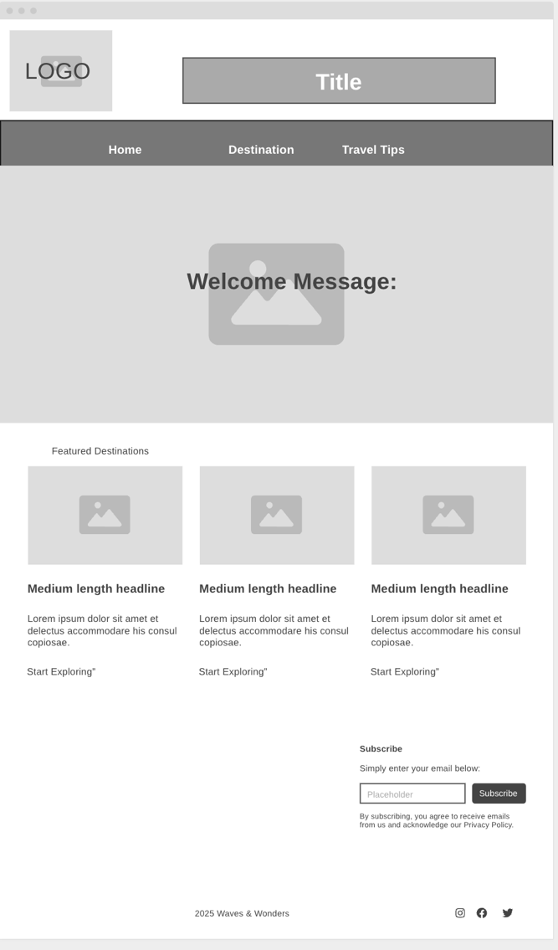

**DESTINATION**

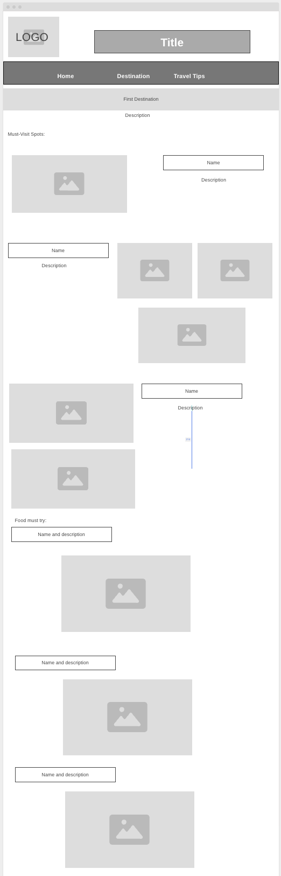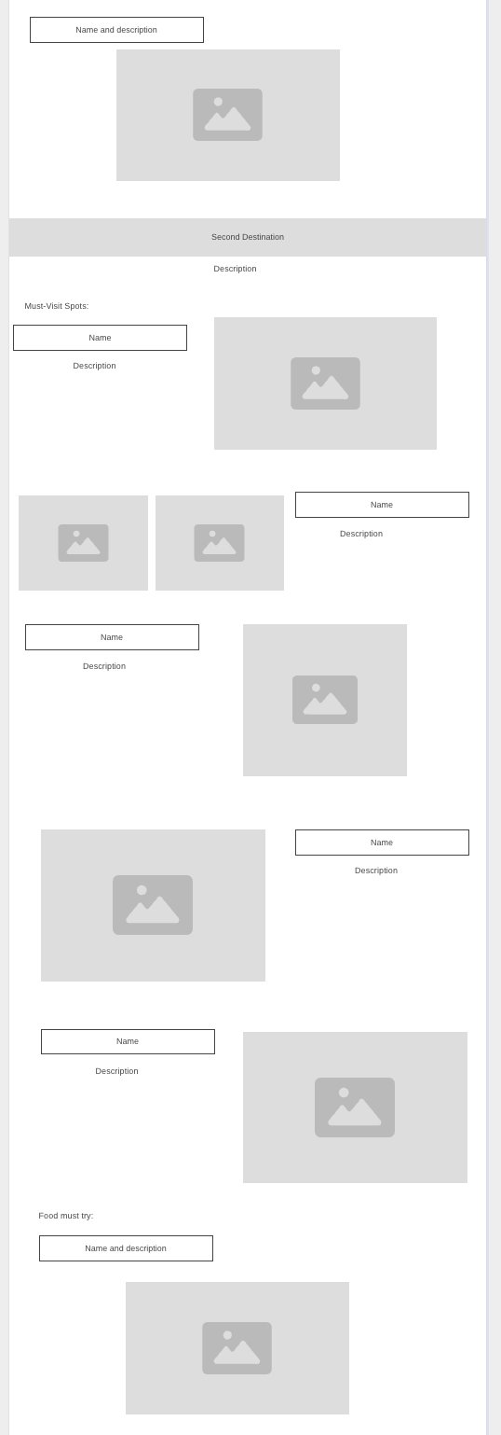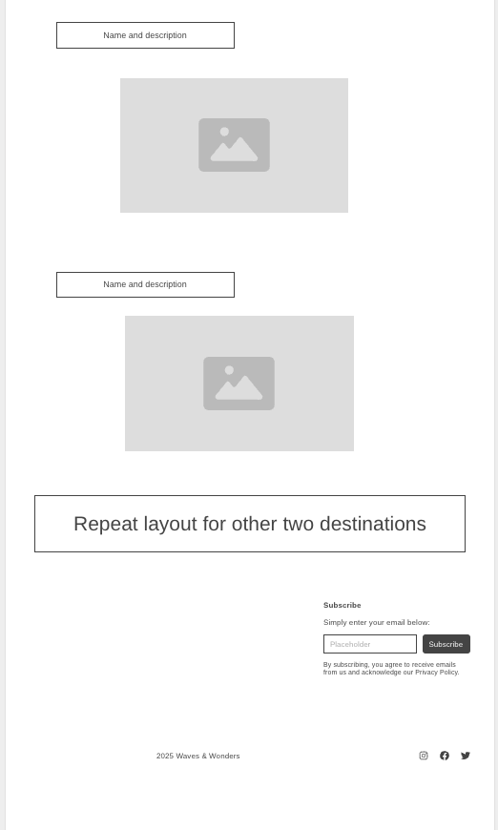

**Travel Tips**

